BRING DAILY: BACK PACK WITH: BAG LUNCH, WATER BOTTLE, HAT, SUNSCREEN, BUGSPRAY, KCF T-SHIRT, SWIMSUIT + TOWEL AND GOOD WALKING SHOES
AUGUST
2019
Sunday | Monday | Tuesday | Wednesday | Thursday | Friday | CLUBS
 |  |  |  | 1 | 2 | MASK MAKING CLUB
 |  |  |  | ZOO  10-3 | TRAVEL DAY TO UNITED KINGDOM  BIKE DAY | KINDNESS CLUB
4 | 5 | 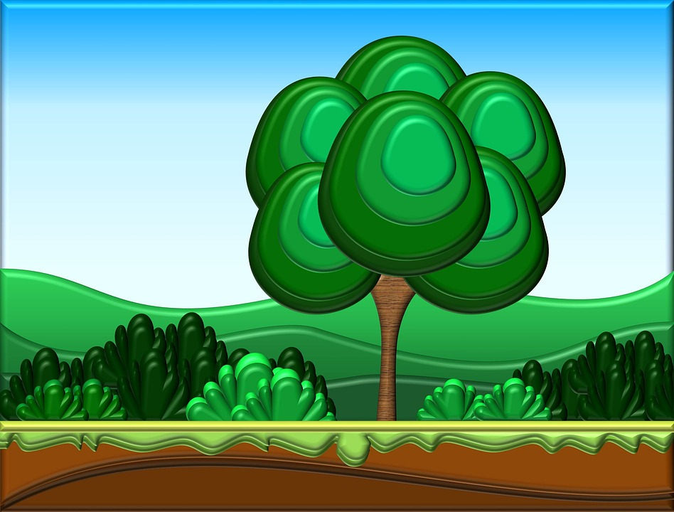 6 | 7 | 8 | 9 | UNDER THE SEA CLUB  YARN CLUB
 | CLOSED  HERITAGE DAY | FISH CREEK PARK  10-3 | HERITAGE PARK  10-3 | CALAWAY PARK  10-3 | TRAVEL DAY TO THAILAND  BIKE DAY
11 | 12 | 13 | 14 | 15 | 16 | FAIRY CLUB  WATER, WATER, WATER CLUB
 | CAMPING THEME DAY  LIBRARY | BOWLING  10-1  WEAR SOCKS | ZOO  10-3 | CALAWAY PARK  10-3 | TRAVEL DAY TO NUNAVUT  BIKE DAY | 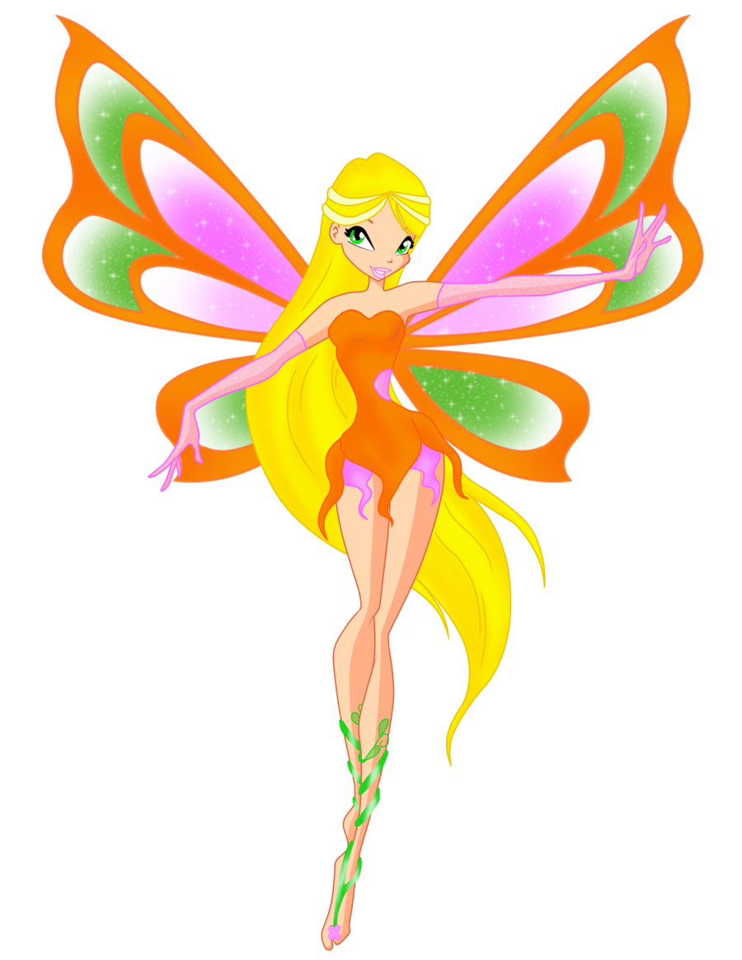
18 | 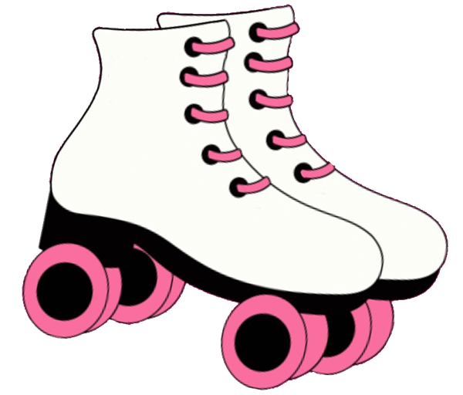 19 | 20 | 21 | 22 | 23 | PET CLUB  YOGA CLUB
 | RECYCLE IT THEME DAY  ALIEN IN LINE | SWIMMING  12-3 | CALAWAY PARK  10-3 | BOW HABITAT STATION  10-3 | TRAVEL DAY TO NAMBIA  BIKE DAY | 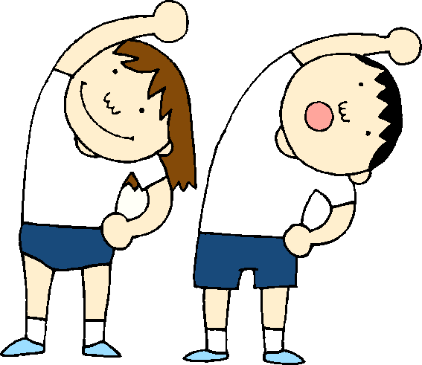
25 | 26 | 27 | 28 | 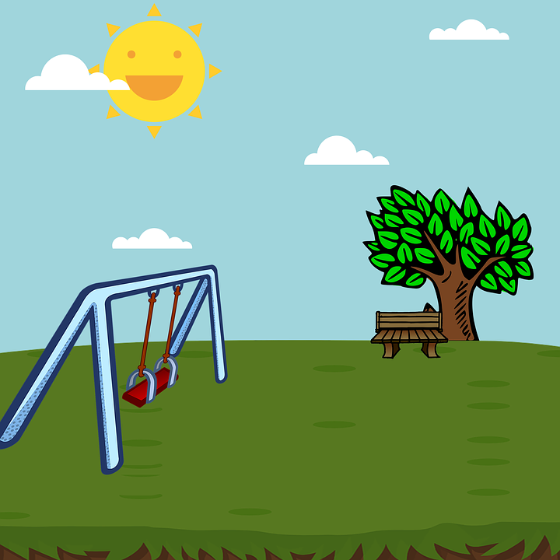 29 | 30 | CHEERIO CLUB  STUFFY CLUB
 | ROCK AROUND THE CLOCK THEME DAY  LIBRARY | BOWLING  10-1  WEAR SOCKS | ZOO  10-3 | BOWNESS PARK  10-3 | END OF SUMMER PARTY!  FUN LUNCH

To get started right away, just click any placeholder text (such as this) and start typing to replace it with your own. | Want to insert a picture from your files or add a shape? You got it! | On the Insert tab of the ribbon, just click the option you need. | Use styles to easily format your Word documents in no time. For example, this text uses the Events style. | View and edit this document in Word on your computer, tablet, or phone. | You can edit and seamlessly save the document to the cloud from Word on your Windows, Mac, Android, or iOS device.

