 | BRING DAILY: BACK PACK WITH: BAG LUNCH, WATER BOTTLE, HAT, SUNSCREEN, BUGSPRAY, KCF T-SHIRT, SWIMSUIT + TOWEL AND GOOD WALKING SHOES
JULY  2019 | 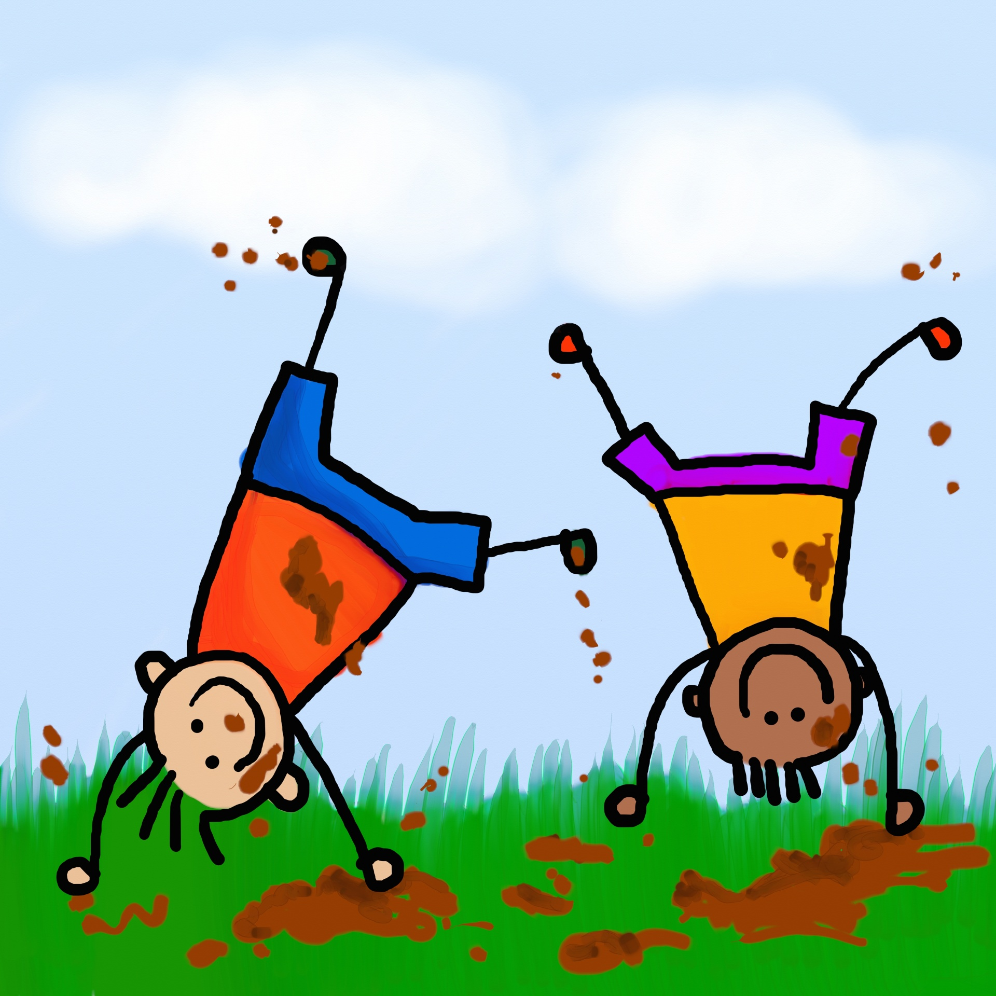
Sunday | Monday | Tuesday | Wednesday | Thursday | Friday | CLUBS
 | 1 | 2 | 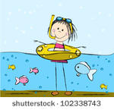 3 | 4 | 5 | HARRY POTTER CLUB
 | CLOSED  HAPPY CANADA DAY! | SCIENCE  WORKSHOP | RILEY PARK  10-3 | SPRUCE MEADOWS  10-3 | STAMPEDE BREAKFAST  TRAVEL DAY TO MEXICO  BIKE DAY | STEM CLUB
7 | 8 | 9 | 10 | 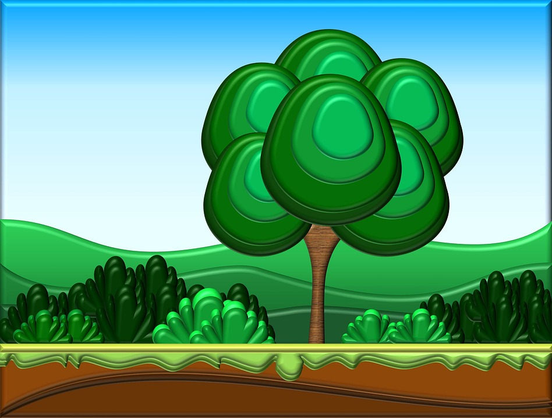 11 | 12 | GARDENING CLUB  KARAOKE/DANCE CLUB
 | BUBBLES THEME DAY  REPTILE GUY | BOWLING  10-1  WEAR SOCKS | ZOO  10-3 | FISH CREEK PARK  10-3 | TRAVEL DAY TO ITALY  BIKE DAY
14 | 15 | 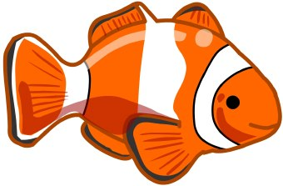 16 | 17 | 18 | 19 | NATURE CLUB  PAINTING CLUB
 | SPACE THEME DAY  LIBRARY | BOW HABITAT STATION  10-3 | CALAWAY PARK  10-3 | SWIMMING  12-3 | TRAVEL DAY TO BRAZIL  BIKE DAY
21 | 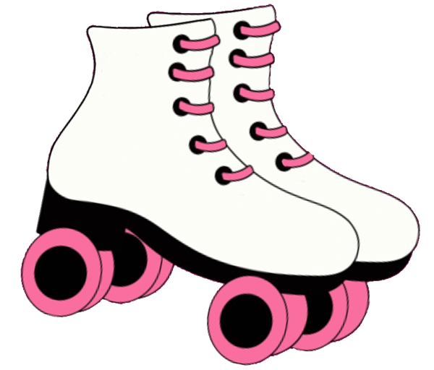 22 | 23 | 24 | 25 | 26 | SPACE CLUB  SEWING CLUB
 | CHOCOLATE THEME DAY  ALIEN IN LINE | BOWLING  10-1 | CALAWAY PARK  10-3 | RILEY PARK  10-3 | TRAVEL DAY TO ICELAND  BIKE DAY
28 | 29 | 30 | 31
 | GROSS THEME DAY  LIBRARY | SWIMMING  12-3 | END OF JULY PARTY AT BOWNESS PARK  10-3 HOTDOG LUNCH

To get started right away, just click any placeholder text (such as this) and start typing to replace it with your own. | Want to insert a picture from your files or add a shape? You got it! |  |  | View and edit this document in Word on your computer, tablet, or phone. | You can edit and seamlessly save the document to the cloud from Word on your Windows, Mac, Android, or iOS device.

